This file contains several in-game screenshots of the game Laboratory Defense.

Here are the screenshots of the perk-choosing scene. The Text here shows details of the chosen perk and it can be read in English or simplified Chinese. (Other parts of the game UI are still in Chinese only.) Only two perks are deliberated here.

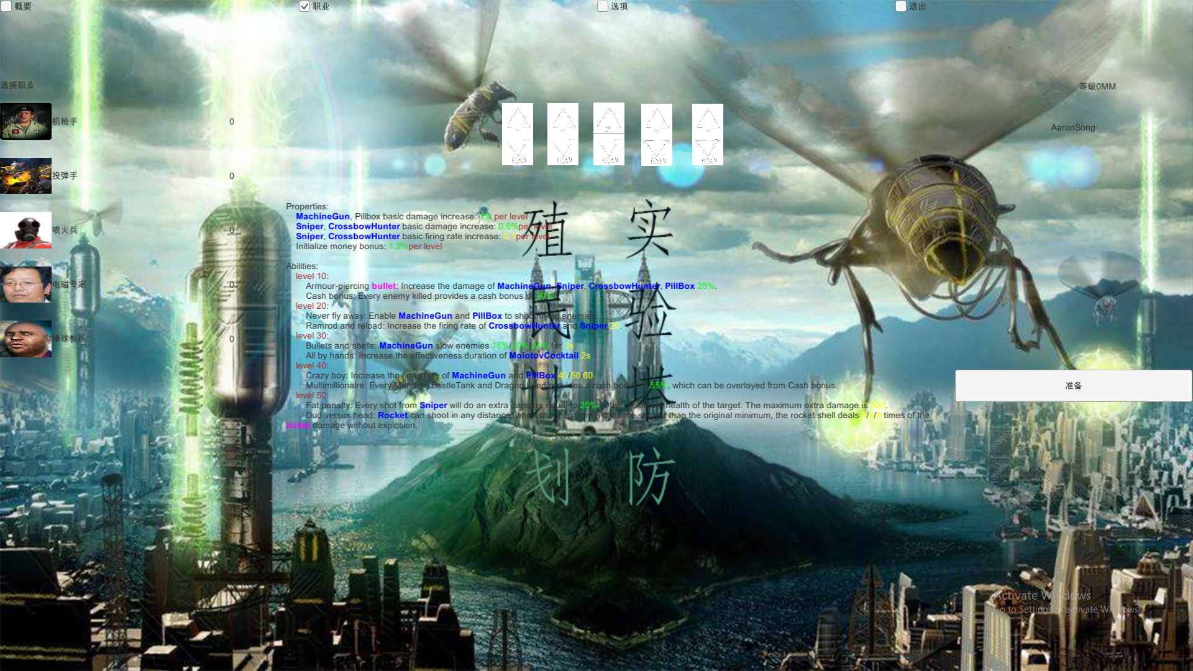

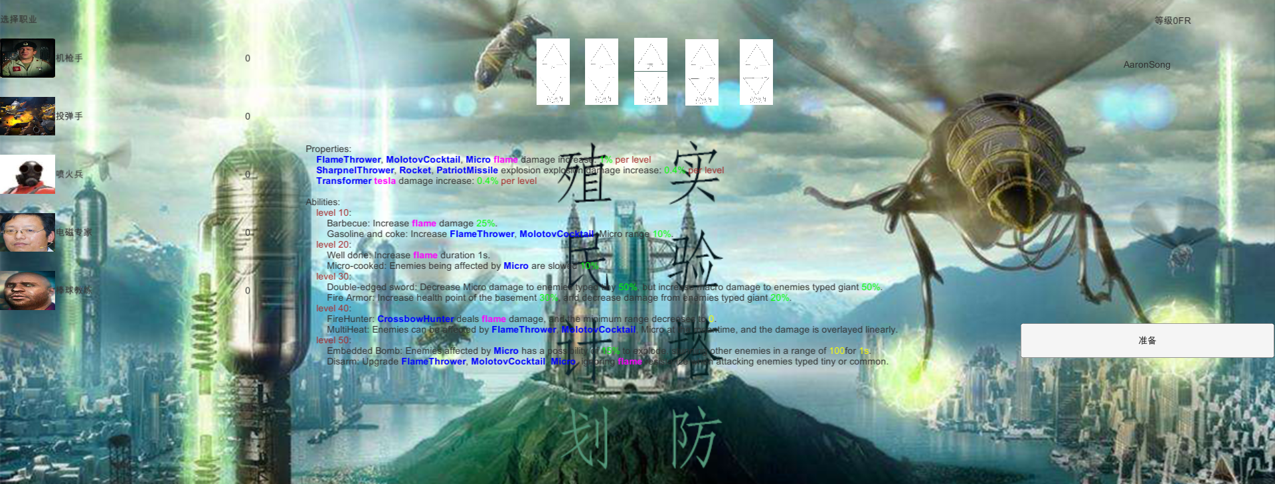

Here are screenshots of the game playing scene. You can see all the thirteen genres of turrets you can build, multiple kinds of enemies, and UI elements of the information of the round, your money and game speed. You may pause the game and elaborate a plan to defeat the enemies.

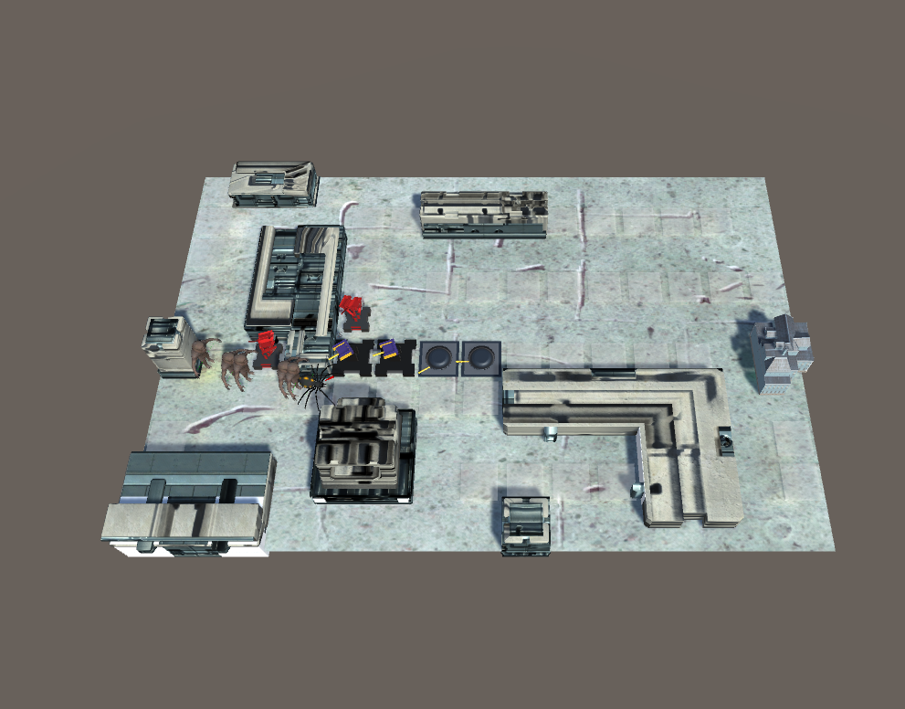

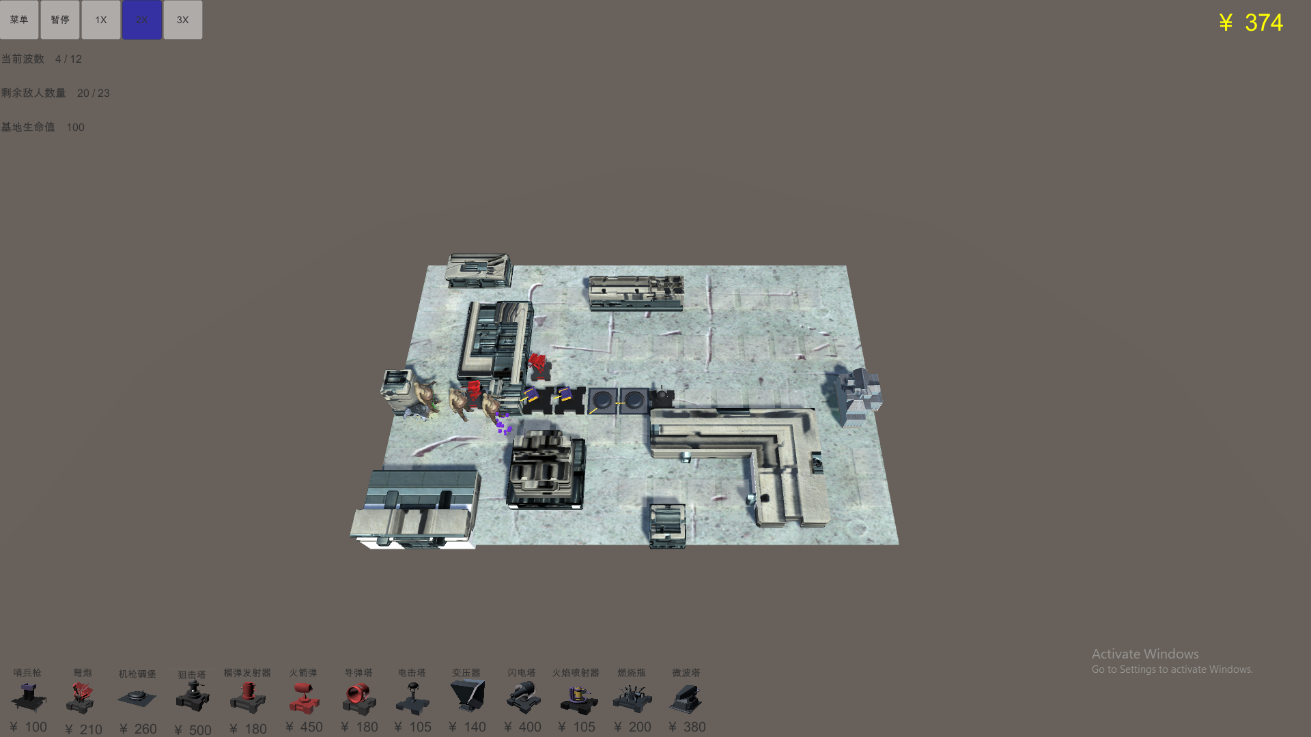

As you can see, the game is not very easy, and I’m losing some health points.

